Kill Switches

GT Off-Road Racing | Data Acquisition

Andrew Hellrigel

7/24/2020

Table of Contents

1.0 Overview 2

1.1 Introduction 2

2.0 Hardware 3

2.1 Circuit 3

2.2 Wiring 3

3.0 Revision History 4

# Overview

## Introduction

Kill switches are required by competition rules and are imperative to the safety of the driver/team. There are two kill switches on the car. One to the left of the drivers left arm, and one on the right side of car, near the top of the firewall.

The kill switches kill the engine.

# Hardware

## Circuit

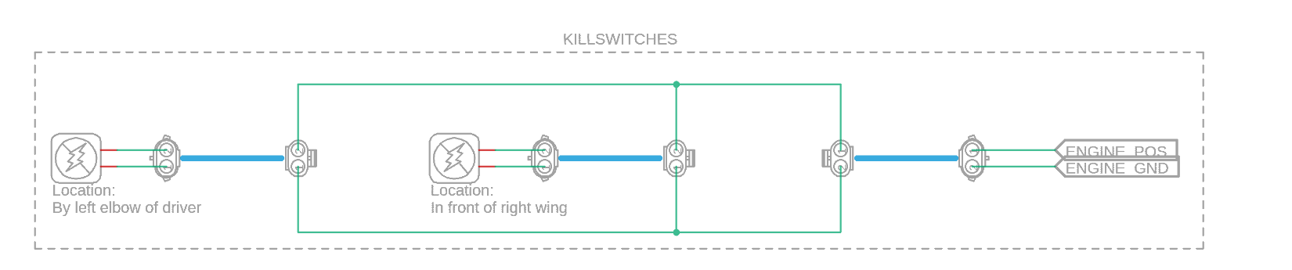

The engine will turn off when you provide a path to ground. This means that for successful operation of the kill switches, they must be wired in parallel so that either switch being pressed will kill the engine.

The on/off switch on the engine is left disconnected, and [Ski-Doo kill switches](https://www.mfgsupply.com/01-171.html) are used instead.

## Wiring

It is also very crucial that the kill switches are wired very robustly because the car will not pass tech inspection during competition if the kill switches do not function. In the past, the wires have broken off the connectors when performing the tug test. Therefore, after crimping, the wires should be soldered to the crimps for extra strength.

# Revision History

7/4/2020 (Andrew Hellrigel) – Wrote first kill switch documentation.

5/16/2022 (Ryan Chen) – Added diagram and additional tips for stronger wiring connections.